Міністерство освіти і науки України

Національний технічний університет України „КПІ”

Факультет інформатики та обчислювальної техніки

Кафедра автоматизованих систем обробки

інформації та управління

**ЗВІТ**

до лабораторних робіт з JS та PHP

з дисципліни “Основи клієнтської розробки”

|  |  |  |  |  |
| --- | --- | --- | --- | --- |
| **Виконав**  **студент** |  | *ІП-61 Кушка Михайло Олександрович* |  |  |
|  |  | (№ групи, прізвище, ім’я, по батькові ) |  |  |
|  |  |  |  |  |
| **Прийняв** |  | *Ковтунець О. В.* |  |  |
|  |  | (посада, прізвище, ім’я, по батькові ) |  |  |

Київ 2017

ЗМІСТ

1. JS 3

Лабораторна робота 1 3

Лабораторна робота 2 4

Лабораторна робота 3 7

Лабораторна робота 4 11

Лабораторна робота 5 16

Лабораторна робота 6 22

Лабораторна робота 7 28

Лабораторна робота 8 37

Лабораторна робота 9 43

Лабораторна робота 10 51

Лабораторна робота 11 56

Лабораторна робота 12 62

2. PHP 65

Лабораторна робота 2 65

Лабораторні роботи 3, 6, 7 69

Лабораторна робота 4 74

Лабораторна робота 5 77

# JS

## Лабораторна робота 1

### Код сайту

<!doctype html>

<html>

<head>

<meta charset='utf-8'>

<title>Try js code</title>

</head>

<body>

<script>

var a = 8, h = 10;

document.write('Square of the right triangle = ', a*h / 2, '.<br>');

var r = 10;

document.write('Square of the circle = ', (Math.PI * Math.pow(r, 2)).toFixed(2), '.<br>');

var a = 3, b = 4;

document.write('Hypotenuse of the right triangle = ', (Math.pow(Math.pow(a,2) + Math.pow(b,2), 0.5)).toFixed(2), '.<br>')

</script>

<p>Using method write of document's object.</p>

</body>

</html>

### Вигляд сайту

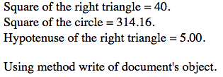

## Лабораторна робота 2

### Код сайту

<!doctype html>

<html>

<head>

<meta charset='utf-8'>

<title>JS functions</title>

</head>

<script>

function area(a, h) {

var s = a*h / 2;

document.write('Area of the right triangle is ', s, '.');

}

function area_rec(obj) {

obj.result.value = Math.pow(obj.side.value, 2);

}

function area_points(obj) {

var x1 = obj.dot1_x.value;

var y1 = obj.dot1_y.value;

var x2 = obj.dot2_x.value;

var y2 = obj.dot2_y.value;

var x3 = obj.dot3_x.value;

var y3 = obj.dot3_y.value;

var s = Math.abs((x1*(y2 - y3) + x2*(y3 - y1) + x3*(y1-y2)) / 2);

obj.dot_result.value = s;

}

function dot_distance(obj) {

var X = obj.X.value;

var y = obj.y.value;

obj.result.value = Math.pow(Math.pow(X,2) + Math.pow(y,2), 0.5);

}

function swap_me(obj) {

var temp = obj.text1.value;

obj.text1.value = obj.text2.value;

obj.text2.value = temp;

}

</script>

<body>

<p>Area of the right triangle.</p>

<form name='triangle'>

Height: <input type='text' size=5 name='height'><br>

Base: <input type='text' size=5 name='base'><br>

<input type='button' value='Calculate' onclick='area(document.triangle.height.value, document.triangle.base.value)'>

</form>

<p>Area of the square.</p>

<form name='square'>

Side: <input type='text' size=7 name='side' onchange='area_rec(square)'><br>

Square: <input type='text' size=7 name='result'><br>

<input type='reset' value='Reset'>

</form>

<p>Area of the triangle using 3 points.</p>

<form name='triangle_dots'>

Dot 1:<br>

&nbsp;&nbsp;X: <input type='text' name='dot1_x'><br>

&nbsp;&nbsp;Y: <input type='text' name='dot1_y'><br>

Dot 2:<br>

&nbsp;&nbsp;X: <input type='text' name='dot2_x'><br>

&nbsp;&nbsp;Y: <input type='text' name='dot2_y'><br>

Dot 3:<br>

&nbsp;&nbsp;X: <input type='text' name='dot3_x'><br>

&nbsp;&nbsp;Y: <input type='text' name='dot3_y'><br>

<input type='text' style='margin-left: 30px;' placeholder="Focus to get the result"

name='dot_result' onfocus='area_points(triangle_dots)'><br>

<input type='reset' value='Reset'>

</form>

<p>Distance to the origin.</p>

<form name='dot'>

X: <input type='text' name='X'><br>

Y: <input type='text' name='y'><br>

<input type='text' name='result' value='Select me to get the result' onselect='dot_distance(dot)'>

</form>

<p>Swap values.</p>

<form name='swap'>

Input some here: <input style='margin-left: 40px;' type='text' name='text1'><br>

Input something different here: <input type='text' name='text2' value='Hit <tab> to swap' onblur='swap_me(swap)'><br>

</form>

</body>

</html>

### Вигляд сайту

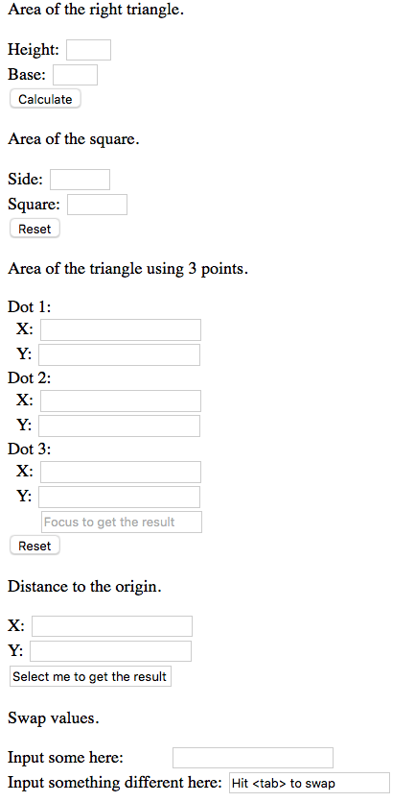

## Лабораторна робота 3

### Код сайту

<!doctype html>

<html>

<head>

<meta charset='utf-8'>

<title>JS if...else blocks</title>

<script>

function maxval(obj) {

var num1 = Number(obj.number1.value);

var num2 = Number(obj.number2.value);

var num3 = Number(obj.number3.value);

var max_val = num1;

if (num2 > max_val)

max_val = num2;

if (num3 > max_val)

max_val = num3;

obj.result.value = max_val;

}

function maxval1(obj) {

var num1 = Number(obj.number1.value);

var num2 = Number(obj.number2.value);

var num3 = Number(obj.number3.value);

obj.result.value = Math.max(Math.max(num1, num2), num3);

}

function findmax(arr) {

var maxval = arr[0];

for (var i = 0; i < arr.length; i++) {

if (arr[i] > maxval)

maxval = arr[i];

}

return maxval;

}

function num_of_maxval(maxval, arr) {

var counter = 0;

for (var i = 0; i < arr.length; i++) {

if (arr[i] == maxval)

counter++;

}

return counter;

}

function max_5(obj) {

var numbers = obj.numbers.value.split(' ');

for (var i = 0; i < numbers.length; i++) {

numbers[i] = Number(numbers[i]);

if (isNaN(numbers[i]))

numbers[i] = 0;

}

alert(numbers);

var maxval = findmax(numbers);

obj.result.value = num_of_maxval(maxval, numbers);

}

function build_triangle(obj) {

var a = Number(obj.side1.value);

var b = Number(obj.side2.value);

var c = Number(obj.side3.value);

var can = false;

if ((a + b > c) && (b + c > c) && (c + a > b)) {

can = true;

}

if (can) {

document.getElementById('can_draw').innerHTML = 'YES';

} else {

document.getElementById('can_draw').innerHTML = 'NO';

}

}

function what_quarter(obj) {

var X = Number(obj.X.value);

var y = Number(obj.y.value);

var quarter;

if (X < 0) {

if (y < 0)

quarter = 3;

else

quarter = 2;

} else {

if (y < 0)

quarter = 4;

else

quarter = 1;

}

obj.answer.value = quarter;

}

</script>

</head>

<body>

<p>Determine the max value.</p>

<form name='max_value'>

Number1: <input type='text' name='number1'><br>

Number2: <input type='text' name='number2'><br>

Number3: <input type='text' name='number3'><br>

Max value: <input type='text' name='result'><br>

<input type='button' value='Determine' onclick='maxval1(max_value)'><br>

<input type='reset'>

</form>

<p>Max value of 5 numbers.</p>

<form name='max_five'>

Enter five numbers separated with space: <input type='text' name='numbers'><br>

Max value: <input type='text' name='result'><br>

<input type='button' value='Determine' onclick='max_5(max_five)'><br>

<input type='reset'>

</form>

<p>Make a triangle.</p>

<form name='triangle'>

First side: <input type='text' name='side1'><br>

Second side: <input type='text' name='side2'><br>

Third side: <input type='text' name='side3'><br>

Can draw the triangle: <span id='can_draw'></span><br>

<input type='button' value='Determine' onclick='build_triangle(triangle)'><br>

<input type='reset'>

</form>

<p>In what quarter?</p>

<form name='dot'>

X: <input type='text' name='X'><br>

Y: <input type='text' name='y'><br>

Quarter: <input type='text' name='answer'><br>

<input type='button' value='Determine' onclick='what_quarter(dot)'><br>

<input type='reset'>

</form>

</body>

</html>

### Вигляд сайту

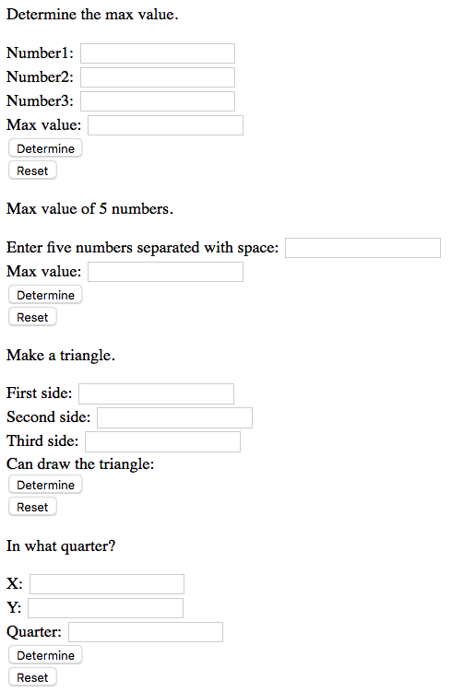

## Лабораторна робота 4

### Код сайту (adding_image.html)

<!doctype html>

<html>

<head>

<meta charset='utf-8'>

<title>Adding image.</title>

</head>

<script>

function add_image(obj) {

var number = Number(obj.n_image.value);

if (number < 1 || number > 3) {

alert('Incorrect image number!');

} else {

document.getElementById('new_image').innerHTML = "<img src='img/img"

+ number + ".jpg' width='200' name='image1' alt='image 1'><br>";

}

}

</script>

<body>

<p>My images.</p>

<img src='img/img1.jpg' width='200' name='image1' alt='image 1'>

<img src='img/img2.jpg' width='200' name='image2' alt='image 2'>

<img src='img/img3.jpg' width='200' name='image3' alt='image 3'><br>

<div id='new_image'></div>

<form name='add'>

<p>Input number of image to add.</p>

<input type='text' name='n_image' size=1><br>

<input type='button' value='Add' onclick='add_image(add)'>

</form>

</body>

</html>

### Вигляд сайту (adding_image.html)

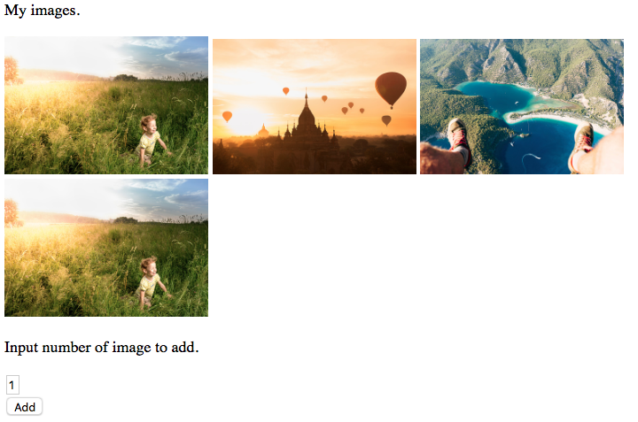

### Код сайту (gallery.html)

<!doctype html>

<html>

<head>

<meta charset='utf-8'>

<title>Swap images</title>

</head>

<script>

function swap_images(obj) {

var a = Number(obj.a1.value);

var b = Number(obj.a2.value);

if (a < 1 || a > 3 || b < 1 || b > 3) {

alert('Images numbers setted incorrect.');

} else {

var temp = document.images[a-1].src;

document.images[a-1].src = document.images[b-1].src;

document.images[b-1].src = temp;

}

}

</script>

<body>

<center>

<p>Images gallery.</p>

<img src='img/img1.jpg' width='200' name='picture1' alt='picture1'>

<img src='img/img2.jpg' width='200' name='picture2' alt='picture2'>

<img src='img/img3.jpg' width='200' name='picture3' alt='picture3'><br>

<form name='swap'>

<p>Images with numbers.</p>

<input type='text' name='a1' size=1><br>

<input type='text' name='a2' size=1><br>

<input type='button' value='Swap' onclick='swap_images(swap)'>

</form>

</center>

</body>

</html>

### Вигляд сайту (gallery.html)

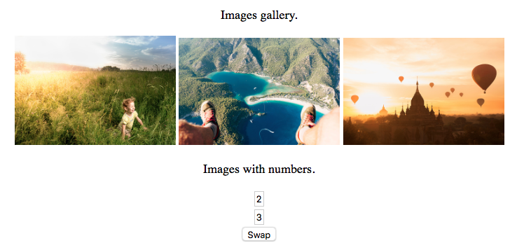

### Код сайту (horizontal_menu.html)

<!doctype html>

<html>

<head>

<meta charset='utf-8'>

<title>Horisontal menu.</title>

</head>

<style>

#arrow {

margin: 0 15px 15px 0;

visibility: hidden;

}

</style>

<script>

function is_active(n, action) {

if (action) {

document.images[n-1].style.visibility = "visible";

} else {

document.images[n-1].style.visibility = "hidden";

}

}

</script>

<body>

<center>

<h2>Content</h2>

<img src="img/arrow.png" id="arrow" alt="arrow" border="0" height="50">

<img src="img/arrow.png" id="arrow" alt="arrow" border="0" height="50">

<img src="img/arrow.png" id="arrow" alt="arrow" border="0" height="50"><br>

<img src="img/img1.jpg" аlt="option 1" border="0" height="50" onmouseover="is_active(1,1)" onmouseout="is_active(1,0)">

<img src="img/img2.jpg" аlt="option 2" border="0" height="50" onmouseover="is_active(2,1)" onmouseout="is_active(2,0)">

<img src="img/img3.jpg" аlt="option 3" border="0" height="50" onmouseover="is_active(3,1)" onmouseout="is_active(3,0)">

</center>

</body>

</html>

### Вигляд сайту (horizontal_menu.html)

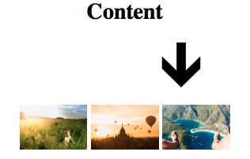

### Код сайту (vertical_menu.html)

<!doctype html>

<html>

<head>

<meta charset='utf-8'>

<title>Vertical menu.</title>

</head>

<script>

function img(n, action) {

if (action) {

document.images[n-1].src = 'img/serpia' + n + '.jpg';

} else {

document.images[n-1].src = 'img/img' + n + '.jpg';

}

}

</script>

<body>

<h2>Content</h2>

<img src="img/img1.jpg" аlt="option 1" border="0" height="50" onmouseover="img(1,1)" onmouseout="img(1,0)"><br>

<img src="img/img2.jpg" аlt="option 2" border="0" height="50" onmouseover="img(2,1)" onmouseout="img(2,0)"><br>

<img src="img/img3.jpg" аlt="option 3" border="0" height="50" onmouseover="img(3,1)" onmouseout="img(3,0)"><br>

</body>

</html>

### Вигляд сайту (vertical_menu.html)

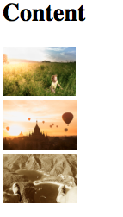

### Код сайту (zoom_effect.html)

<!doctype html>

<html>

<head>

<meta charset='utf-8'>

<title>Zoom effect.</title>

</head>

<script>

function zoom_image(zoom_flag) {

if (zoom_flag) {

document.images[0].width += 30;

document.images[0].height += 30;

} else {

document.images[0].width -= 30;

document.images[0].height -= 30;

}

}

</script>

<body>

<center>

<img src='img/img3.jpg' width='400' name='image3' onmouseover='zoom_image(1)' onmouseout='zoom_image(0)' alt='image 3'>

</center>

</body>

</html>

### Вигляд сайту (zoom_effect.html)

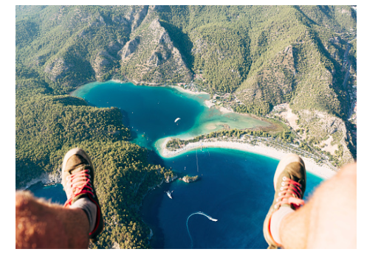

## Лабораторна робота 5

### Код сайту (calc_area.html)

<!doctype html>

<html>

<head>

<meta charset='utf-8'>

<title>Calculate area of the figure.</title>

</head>

<script>

function test(k) {

var a = figures.data.value;

if (a == '') {

alert('Enter value!');

} else {

figures.result.value = k * Math.pow(a, 2);

}

}

</script>

<body>

<form name='figures'>

Enter value <input type='text' name='data' size=10><br>

Select a figure.<br>

<input type='radio' name='figure' value=1 onclick='test(figures.elements[1].value)'>square<br>

<input type='radio' name='figure' value=3.14 onclick='test(figures.elements[2].value)'>circle<br>

<input type='radio' name='figure' value=0.42 onclick='test(figures.elements[3].value)'>triangle<br>

<input type='reset' value='Reset'><hr>

Area: <input type='text' name='result' size=10>

</form>

</body>

</html>

### Вигляд сайту (calc_area.html)

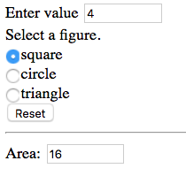

### Код сайту (horizontal_line.html)

<!doctype html>

<html>

<head>

<meta charset='utf-8'>

<title>Horisontal line.</title>

</head>

<script>

function set_width(obj) {

if (obj.elements[0].checked) {

document.getElementById('my_line').width = obj.elements[0].value;

} else if (obj.elements[1].checked) {

document.getElementById('my_line').width = obj.elements[1].value;

} else if (obj.elements[2].checked) {

document.getElementById('my_line').width = obj.elements[2].value;

} else if (obj.elements[3].checked) {

document.getElementById('my_line').width = obj.elements[3].value;

}

}

function set_position(obj) {

if (obj.elements[0].checked) {

document.getElementById('my_line').align = 'left';

} else if (obj.elements[1].checked) {

document.getElementById('my_line').align = 'center';

} else if (obj.elements[2].checked) {

document.getElementById('my_line').align = 'right';

}

}

</script>

<body>

<p>Set parameters for the horisontal line.</p>

<form name='line_width'>

Line width:<br>

<input type='radio' name='param' value=300> 300<br>

<input type='radio' name='param' value=500> 500<br>

<input type='radio' name='param' value=800> 800<br>

<input type='radio' name='param' value=1200> 1200<br>

<input type='button' value='Set' onclick='set_width(line_width)'>

</form>

<form name='line_position'>

<br>Line position:<br>

<input type='radio' name='param' value=l> Left<br>

<input type='radio' name='param' value=c> Center<br>

<input type='radio' name='param' value=r> Right<br>

<input type='button' value='Set' onclick='set_position(line_position)'>

</form>

<hr id='my_line'>

</body>

</html>

### Вигляд сайту (horizontal_line.html)

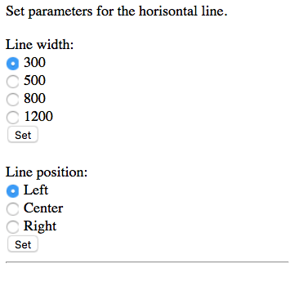

### Код сайту (questionnaire.html)

<!doctype html>

<html>

<head>

<meta charset='utf-8'>

<title>Questionnaire</title>

</head>

<script>

function process_data(obj) {

var gender, age, marital_status;

if (obj.gender[0].checked) {

gender = obj.gender[0].value;

} else {

gender = obj.gender[1].value;

}

age = Number(obj.age.value);

if (obj.marital[0].checked) {

marital_status = obj.marital[0].value;

} else if (obj.marital[1].checked) {

marital_status = obj.marital[1].value;

} else {

marital_status = obj.marital[2].value;

}

document.getElementById('result').innerHTML = 'gender: ' + gender + '<br>';

document.getElementById('result').innerHTML += 'age: ' + age + '<br>';

document.getElementById('result').innerHTML += 'marital status: ' + marital_status + '<br>';

}

</script>

<body>

<p>Simple questionnaire.</p>

<form name='questionnaire'>

What is your gender?<br>

<input type='radio' name='gender' checked value=male> Male<br>

<input type='radio' name='gender' value=female> Female<br>

What is your age?<br>

<input type='text' name='age' size=3>

What is your marital status?<br>

<input type='radio' name='marital' checked value=single> Single<br>

<input type='radio' name='marital' value=engaged> Engaged<br>

<input type='radio' name='marital' value=married> Married<br>

<input type='button' value='Send data' onclick='process_data(questionnaire)'>

</form><hr>

<div id='result'></div>

</body>

</html>

### Вигляд сайту (questionnaire.html)

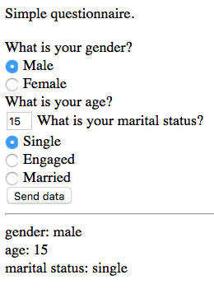

### Код сайту (text_wrapping.html)

<!doctype html>

<html>

<head>

<meta charset='utf-8'>

<title>Text wrapping.</title>

</head>

<script>

function change(obj) {

if (obj.elements[0].checked) {

document.my_picture.align = "left";

} else {

document.my_picture.align = "right";

}

}

function reset_() {

document.my_picture.align = "left";

}

</script>

<body>

<p>Image text wrapping.</p>

<form name='wrapping'>

Choose wrapping parameter.<br>

<pre>

<input type='radio' name='wrap' checked value=l> Left alignment

<input type='radio' name='wrap' value=r> Right alignment

</pre>

<input type='button' value='See changes' onclick='change(wrapping)'>

<input type='reset' onclick='reset_()'>

</form>

<table bgcolor='F8F8FF'>

<tr>

<td>

Lorem Ipsum не є випадковим набором літер. Він походить з уривку

класичної латинської літератури 45 року до н.е., тобто має більш як 2000-річну історію.

Річард Макклінток, професор латини з коледжу Хемпдін-Сидні, що у Вірджінії, вивчав одне з

найменш зрозумілих латинських слів - consectetur - з уривку Lorem Ipsum, і у пошуку цього слова

в класичній літературі знайшов безсумнівне джерело.

<img src='img/img1.jpg' name='my_picture' align=left border=3 width=300>

Lorem Ipsum походить з розділів 1.10.32 та 1.10.33 цицеронівського "de Finibus Bonorum et Malorum"

("Про межі добра і зла"), написаного у 45 році до н.е. Цей трактат з теорії етики був дуже

популярним в епоху Відродження. Перший рядок Lorem Ipsum, "Lorem ipsum dolor sit amet..."

походить з одного з рядків розділу 1.10.32.

</td>

</tr>

</table>

</body>

</html>

### Вигляд сайту (text_wrapping.html)

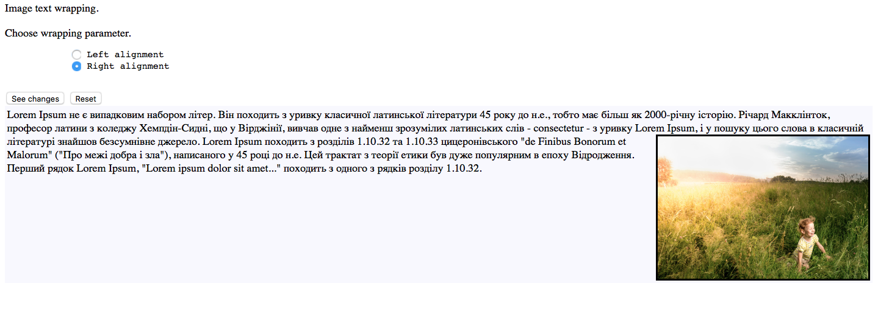

## Лабораторна робота 6

### Код сайту (courses.html)

<!doctype html>

<html>

<head>

<meta charset='utf-8'>

<title>Courses</title>

</head>

<style>

#my_form {

margin-left: 40%;

}

#my_form input[type=button] {

margin-left: 120px;

}

</style>

<body>

<h2 align='center'>Courses selector</h2>

<form name='courses' id='my_form'>

Please set courses which you want to complete<br>

<input type='checkbox' name='course1' onclick='show_me(1)' value=300> Machine Learning with Python<br>

<div name='course_features1' style='display: none;'>

How fast do you want to complete this course?<br>

<input type='radio' name='duration1' value=100> 3 weeks<br>

<input type='radio' name='duration1' value=70> 4 weeks<br>

<input type='radio' name='duration1' value=0 checked> 8 weeks<br>

In what language do you want to take the course?<br>

<input type='radio' name='language1' value=0 checked> English<br>

<input type='radio' name='language1' value=100> French<br>

<input type='radio' name='language1' value=100> Ukrainian<br>

In what form do you want to take the course?<br>

<input type='radio' name='course_form1' value=0 checked> Online<br>

<input type='radio' name='course_form1' value=300> In class<hr width=350 align='left'>

<div id='price1'></div>

<div id='total_price1'></div>

<input type='button' value='Calculate' onclick='calculate_price(1)'>

</div><hr width=350 align='left'><hr width=350 align='left'>

<input type='checkbox' name='course2' onclick='show_me(2)' value=150> Scikit-learn for Machine Learning<br>

<div name='course_features2' style='display: none;'>

How fast do you want to complete this course?<br>

<input type='radio' name='duration2' value=100> 3 weeks<br>

<input type='radio' name='duration2' value=70> 4 weeks<br>

<input type='radio' name='duration2' value=0 checked> 8 weeks<br>

In what language do you want to take the course?<br>

<input type='radio' name='language2' value=0 checked> English<br>

<input type='radio' name='language2' value=100> French<br>

<input type='radio' name='language2' value=100> Ukrainian<br>

In what form do you want to take the course?<br>

<input type='radio' name='course_form2' value=0 checked> Online<br>

<input type='radio' name='course_form2' value=300> In class<hr width=350 align='left'>

<div id='price2'></div>

<div id='total_price2'></div>

<input type='button' value='Calculate' onclick='calculate_price(2)'>

</div><hr width=350 align='left'><hr width=350 align='left'>

<input type='checkbox' name='course3' onclick='show_me(3)' value=500> Deep learning<br>

<div name='course_features3' style='display: none;'>

How fast do you want to complete this course?<br>

<input type='radio' name='duration3' value=100> 3 weeks<br>

<input type='radio' name='duration3' value=70> 4 weeks<br>

<input type='radio' name='duration3' value=0 checked> 8 weeks<br>

In what language do you want to take the course?<br>

<input type='radio' name='language3' value=0 checked> English<br>

<input type='radio' name='language3' value=100> French<br>

<input type='radio' name='language3' value=100> Ukrainian<br>

In what form do you want to take the course?<br>

<input type='radio' name='course_form3' value=0 checked> Online<br>

<input type='radio' name='course_form3' value=300> In class<hr width=350 align='left'>

<div id='price3'></div>

<div id='total_price3'></div>

<input type='button' value='Calculate' onclick='calculate_price(3)'>

</div>

<input type='reset' onclick='total_price=0;'>

</form>

</body>

<script>

var total_price = 0;

function calculate_price(n) {

var current_price = 0;

if (document.getElementsByName('duration' + n)[0].checked) {

current_price += Number(document.getElementsByName('duration' + n)[0].value);

} else if (document.getElementsByName('duration' + n)[1].checked) {

current_price += Number(document.getElementsByName('duration' + n)[1].value);

} else if (document.getElementsByName('duration' + n)[2].checked) {

current_price += Number(document.getElementsByName('duration' + n)[2].value);

}

if (document.getElementsByName('language' + n)[0].checked) {

current_price += Number(document.getElementsByName('language' + n)[0].value);

} else if (document.getElementsByName('language' + n)[1].checked) {

current_price += Number(document.getElementsByName('language' + n)[1].value);

} else if (document.getElementsByName('language' + n)[2].checked) {

current_price += Number(document.getElementsByName('language' + n)[2].value);

}

if (document.getElementsByName('course_form' + n)[0].checked) {

current_price += Number(document.getElementsByName('course_form' + n)[0].value);

} else if (document.getElementsByName('course_form' + n)[1].checked) {

current_price += Number(document.getElementsByName('course_form' + n)[1].value);

}

total_price += current_price;

document.getElementById('price' + n).innerHTML = 'Your current price is ' + current_price;

document.getElementById('total_price' + n).innerHTML = 'Your total price is ' + total_price;

}

function show_me(n) {

if (document.getElementsByName('course' + n)[0].checked) {

document.getElementsByName('course_features' + n)[0].style.display = 'block';

} else {

document.getElementsByName('course_features' + n)[0].style.display = 'none';

}

}

</script>

</html>

### Вигляд сайту (courses.html)

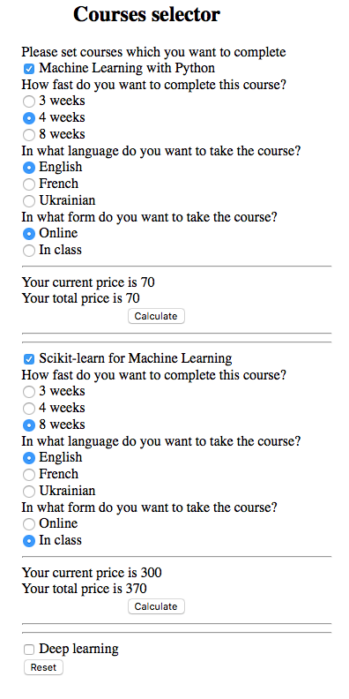

### Код сайту (reader.html)

<!doctype html>

<html>

<head>

<meta charset='utf-8'>

<title>Questionnaire</title>

</head>

<script>

var s = 'You like: \r\n';

function set(info) {

s += info + '\r\n';

document.form2.area.value = s;

}

</script>

<body bgcolor='F8F8FF'>

<center>

<p>Questionnaire</p>

<form name='form1'>

<h4>Enter the name of your favourite magazine.</h4>

<input type='text' name='magazine' size=45><br>

</form>

<form name='form2'>

<h4>What do you like in this magazine?</h4>

<table border=3>

<tr>

<td>

<input type='checkbox' name='chk1' value='Style of submission' onclick='set(form2.elements[0].value)'> Style of submission<br>

<input type='checkbox' name='chk1' value='Reliability of information' onclick='set(form2.elements[1].value)'> Reliability of information<br>

<input type='checkbox' name='chk1' value='Design and decoration' onclick='set(form2.elements[2].value)'> Design and decoration<br>

</td>

</tr>

</table>

<textarea name='area' cols=35 rows=7></textarea><br>

<input type='reset'>

</form>

</center>

</body>

</html>

### Вигляд сайту (reader.html)

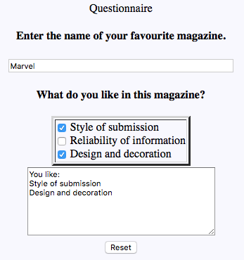

### Код сайту (translator.html)

<!doctype html>

<html>

<head>

<meta charset='utf-8'>

<title>Translator</title>

</head>

<script>

function grant() {

var salary = 0;

if (document.languages.lang[0].checked) {

salary += Number(document.languages.lang[0].value);

}

if (document.languages.lang[1].checked) {

salary += Number(document.languages.lang[1].value);

}

if (document.languages.lang[2].checked) {

salary += Number(document.languages.lang[2].value);

}

document.languages.salary.value = 'Your expected salary is ' + salary + '$.';

}

</script>

<body>

<h3>Translator questionnaire.</h3>

Check languages which you know<br>

<form name='languages'>

<input type='checkbox' name='lang' value=100> ukrainian<br>

<input type='checkbox' name='lang' value=200> english<br>

<input type='checkbox' name='lang' value=300> chinese<br>

<input type='button' value='Get salary' onclick='grant()'><hr>

<input type='text' size=50 name='salary'><br>

<input type='reset'>

</form>

</body>

</html>

### Вигляд сайту (translator.html)

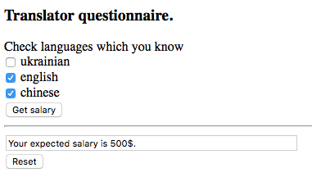

## Лабораторна робота 7

### Код сайту (online_shop.html)

<!doctype html>

<html>

<head>

<meta charset='utf-8'>

<title>Online Shop</title>

</head>

<script>

var sum = 0;

function calc() {

// var item=shop.items.value;

var price = shop.prices.value;

var n_items = shop.no_items.value;

sum += price * n_items;

}

function get_price() {

shop.price.value = sum;

}

</script>

<body>

<form name='shop' align=center>

<table border=3 align=center cellpadding=5 cellspacing=6 bgcolor=silver>

<tr>

<th>Item</th>

<th>Price</th>

<th>No. items</th>

</tr>

<tr>

<td>

<select size=4 name='items'>

<option value='magazine'>Meat</option>

<option value='beer'>Beer</option>

<option value='wine'>Wine</option>

<option value='drugs'>Drugs</option>

</select>

</td>

<td>

<select size=5 name='prices'>

<option value='5'>5$</option>

<option value='10'>10$</option>

<option value='15'>15$</option>

<option value='20'>20$</option>

<option value='50'>50$</option>

</select>

</td>

<td>

<select size=5 name='no_items' onchange='calc()'>

<option value='1'>1</option>

<option value='2'>2</option>

<option value='3'>3</option>

<option value='4'>4</option>

<option value='5'>5</option>

</select>

</td>

</tr>

</table>

Shopping price:

<input type='text' name='price' size=5><br>

<input type='button' value='Result' onclick='get_price()'><br>

<input type='reset' onclick='sum=0'>

</form>

</body>

</html>

### Вигляд сайту (online_shop.html)

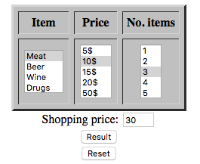

### Код сайту (set_table.html)

<!doctype html>

<html>

<head>

<meta charset='utf-8'>

<title>Set table</title>

</head>

<style>

#my_table {

width: 500px;

height: 400px;

background-repeat: no-repeat;

}

</style>

<script>

var cell = 1;

function change_color(color) {

document.getElementById('my_table').style.backgroundColor = color;

document.getElementById('my_table').style.backgroundImage = 'url()';

}

function change_image(image) {

document.getElementById('my_table').style.backgroundImage = image;

document.getElementById('my_table').style.backgroundColor = '';

}

function use_both(is_checked, color, image) {

if (is_checked) {

document.getElementById('my_table').style.backgroundColor = color;

document.getElementById('my_table').style.backgroundImage = image;

} else {

document.getElementById('my_table').style.backgroundColor = '';

document.getElementById('my_table').style.backgroundImage = 'url()';

}

}

function cell_change_color() {

var my_cell = set_table.cell_no.value;

var my_color = set_table.color_no.value;

my_cell -= 1;

if (my_cell < 2) {

document.getElementById('my_table').rows[0].cells[my_cell].style.backgroundColor = my_color;

} else {

my_cell -= 2;

document.getElementById('my_table').rows[1].cells[my_cell].style.backgroundColor = my_color;

}

}

</script>

<body>

<h3>Table</h3>

<table id='my_table' border=1>

<tr>

<td></td>

<td></td>

</tr>

<tr>

<td></td>

<td></td>

</tr>

</table>

<form name='set_table'>

<p>Select table's background color</p>

<select name='color' onchange='change_color(set_table.color.value)'>

<option value='silver'>Silver</option>

<option value='red'>Red</option>

<option value='pink'>Pink</option>

<option value='green'>Green</option>

<option value='yellow'>Yellow</option>

</select>

<p>Select background image</p>

<select name='image' onchange='change_image(set_table.image.value)'>

<option value='url("img/img1.jpg")'>Image1</option>

<option value='url("img/img2.jpg")'>Image2</option>

<option value='url("img/img3.jpg")'>Image3</option>

</select>

<p><input type='checkbox' name='both' onclick='use_both(set_table.both.checked, set_table.color.value, set_table.image.value)'> use both: color and image</p>

<p>Select background color for every cell</p>

<table border=3 cellpadding=5 cellspacing=6 bgcolor=silver>

<tr>

<th>Cell No.</th>

<th>Color</th>

</tr>

<tr>

<td>

<select size=4 name='cell_no' onchange='cell=set_table.cell_no.value'>

<option value='1'>1</option>

<option value='2'>2</option>

<option value='3'>3</option>

<option value='4'>4</option>

</select>

</td>

<td>

<select size=5 name='color_no' onchange='cell_change_color()'>

<option value='silver'>Silver</option>

<option value='red'>Red</option>

<option value='pink'>Pink</option>

<option value='green'>Green</option>

<option value='yellow'>Yellow</option>

</select>

</td>

</tr>

</table>

</form>

</body>

</html>

### Вигляд сайту (set_table.html)

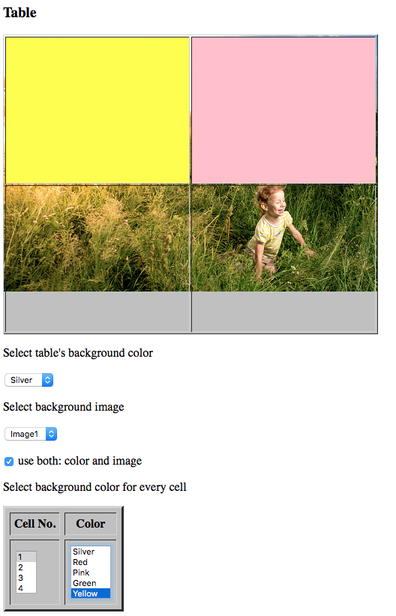

### Код сайту (towns.html)

<!doctype html>

<html>

<head>

<meta charset='utf-8'>

<title>Towns</title>

</head>

<script>

var sum = 0;

function eq() {

var q = test.question.value;

var a = test.answer.value;

if (a == q) {

sum += 1;

}

}

function get_result() {

test.result.value = sum;

}

</script>

<body>

<h3 align=center>Towns and places</h3>

<form name='test'>

<table border=3 align=center cellpadding=5 cellspacing=6 bgcolor=silver>

<tr>

<th>Place</th>

<th>In town</th>

</tr>

<tr>

<td>

<select size=7 name='question' onchange='q=test.question.value'>

<option value='mad'>Museum Prado</option>

<option value='ber'>Reigstag</option>

<option value='mil'>La Scala operum</option>

<option value='ier'>The wall of cry</option>

<option value='mek'>Glory stone Kaab</option>

<option value='par'>Triumf arch</option>

<option value='new'>The Statue of Liberty</option>

<option value='lon'>Tower</option>

</select>

</td>

<td>

<select size=7 name='answer' onchange='eq()'>

<option value='mek'>Mecca</option>

<option value='ier'>Herusalim</option>

<option value='mil'>Milan</option>

<option value='par'>Paris</option>

<option value='mad'>Madrid</option>

<option value='lon'>London</option>

<option value='new'>New York</option>

<option value='ber'>Berlin</option>

</select>

</td>

</tr>

</table>

Number of correct answers

<input type='text' name='result' size=5><br>

<input type='button' value='Result' onclick='get_result()'><br>

<input type='reset' onclick='sum=0'>

</form>

</body>

</html>

### Вигляд сайту (towns.html)

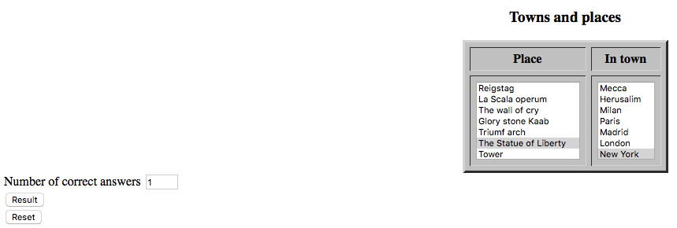

### Код сайту (translator.html)

<!doctype html>

<html>

<head>

<meta charset='utf-8'>

<title>Translator</title>

</head>

<script>

var s = '';

var sum = 0;

function gr(obj, m) {

var r = 100 * (Number(obj.elements[0][m].value) + 1);

s += obj.elements[0][m].text + '\r\n';

obj.result_text.value = s;

sum += r;

obj.result.value = r;

}

</script>

<body>

<form name='questionnaire'>

<h3>Questionnaire</h3>

<table border=3 bgcolor=silver>

<tr>

<th>Selected language</th>

<th>Result</th>

</tr>

<tr>

<td valign=top>

<select name='data' size=3 onchange='gr(questionnaire, questionnaire.data.value)'>

<option value=0>ukrainian

<option value=1>english

<option value=2>chinese

</select>

<input type='text' name='result' size=15>

</td>

<td>

<textarea name='result_text' cols=15 rows=6></textarea>

<input type='button' value='Sum' onclick='questionnaire.result_group.value=sum'>

<input type='text' name='result_group' size=10>

</td>

</tr>

</table>

<input type='reset' value='Cancel' onclick='sum=0;s=""'>

</form>

</body>

</html>

### Вигляд сайту (translator.html)

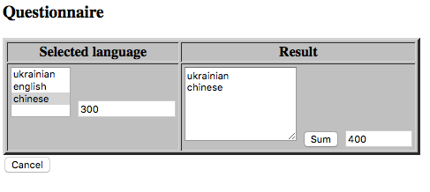

## Лабораторна робота 8

### Код сайту (division.html)

<!doctype html>

<html>

<head>

<meta charset='utf-8'>

<title>Division</title>

</head>

<body>

<form name='division'>

<p>Get all dividers of the number</p>

Enter number <input type='text' name='number'><br>

<input type='button' value='Get' onclick='get_div()'>

<textarea name='result' rows=10></textarea>

</form>

</body>

<script>

function get_div() {

var number = Number(division.number.value);

division.result.value = 1 + '\n';

for (var i = 2; i <= Math.floor(number / 2); i++) {

if (number % i == 0) {

division.result.value += i + '\n';

}

}

division.result.value += number + '\n';

}

</script>

</html>

### Вигляд сайту (division.html)

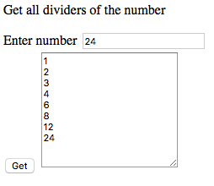

### Код сайту (lucky_tickets.html)

<!doctype html>

<html>

<head>

<meta charset='utf-8'>

<title>Lucky tickets</title>

</head>

<body>

<textarea id='lucky' cols=10 rows=40></textarea>

</body>

<script>

var counter = 0;

var number;

function div(val, by){

return (val - val % by) / by;

}

for (var i = 100000; i <= 999999; i++) {

number = i;

var first = 0;

var last = 0;

for (var j = 0; j < 3; j++) {

first += number % 10;

number = div(number, 10);

}

for (var j = 0; j < 3; j++) {

last += number % 10;

number = div(number, 10);

}

if (first == last) {

document.getElementById('lucky').value += i + '\n';

}

}

</script>

</html>

### Вигляд сайту (lucky_tickets.html)

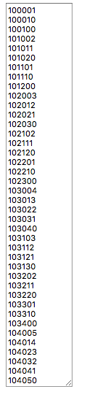

### Код сайту (nsd.html)

<!doctype html>

<html>

<head>

<meta charset='utf-8'>

<title>NSD</title>

</head>

<script>

function nod(obj) {

var n = numbers.numb1.value;

var m = numbers.numb2.value;

var p = n % m;

while (p != 0) {

n = m;

m = p;

p = n % m;

}

obj.result.value = m;

}

</script>

<body>

<form name='numbers'>

Enter number 1 <input type='text' name='numb1' size=8><br>

Enter number 2 <input type='text' name='numb2' size=8><br>

Greatest common divisor <input type='text' name='result' size=8><br>

<input type='button' value='Calculate' onclick='nod(numbers)'>

<input type='reset'>

</form>

</body>

</html>

### Вигляд сайту (nsd.html)

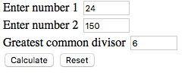

### Код сайту (perfect_number.html)

<!doctype html>

<html>

<head>

<meta charset='utf-8'>

<title>Perfect numbers</title>

</head>

<script>

var n=parseInt(prompt('Enter natural number', 6));

var sum = n-1;

var temp = n;

for(var i = 2; n>1; i++){

if(!(n % i)) {

sum -= i;

n = n / i;

} else {

i++;

}

}

if (!sum) {

alert("Number " + temp + " is perfect");

} else {

alert("Number " + temp + " is not perfect");

}

</script>

<body>

</body>

</html>

### Вигляд сайту (perfect_number.html)

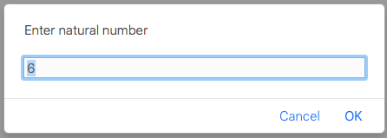

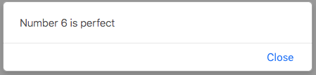

### Код сайту (swap_number.html)

<!doctype html>

<html>

<head>

<meta charset='utf-8'>

<title>Swap number</title>

</head>

<script>

function swap_number() {

var number = Number(form1.number.value);

var swapped = 0;

var temp;

var answer = '';

if (number < 10) {

form1.result.value = number;

} else {

var str_numb = number.toString();

var n = str_numb.length;

for (var i = 0; i < n; i++) {

temp = str_numb.slice(n-1-i, n-i);

answer += temp;

}

form1.result.value = answer;

}

}

</script>

<body>

<form name='form1'>

Enter number <input type='text' name='number'><br>

Swap number <input type='text' name='result'><br>

<input type='button' value='Calculate' onclick='swap_number()'>

</form>

</body>

</html>

### Вигляд сайту (swap_number.html)

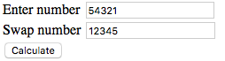

### Код сайту (textarea.html)

<!doctype html>

<html>

<head>

<meta charset='utf-8'>

<title>Text area</title>

</head>

<script>

function property_obj(obj) {

var result = '';

for (var i in obj) {

result += obj.data.value + "." + i + " = " + (obj.data)[i]+ "\r\n";

}

result += "\n\r"

properties.data.value = result;

}

</script>

<body>

<form name='properties'>

<input type='button' value='Process' onclick='property_obj(properties)'><hr>

<textarea name='data' cols=80 rows=20 id=1>Text</textarea><hr>

<input type='reset'>

</form>

</body>

</html>

### Вигляд сайту (textarea.html)

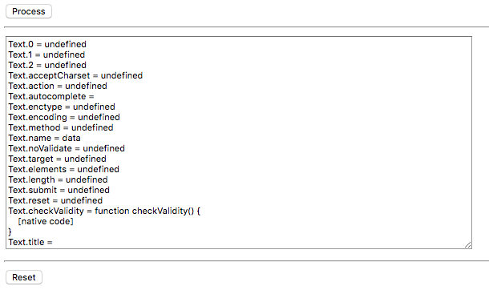

## Лабораторна робота 9

### Код сайту (current_time.html)

<!doctype html>

<html>

<head>

<meta charset='utf-8'>

<title>Current time</title>

</head>

<script>

function get_time() {

var t = new Date;

var h = t.getHours();

var m = t.getMinutes();

var s = t.getSeconds();

var res = '';

if (h < 10) {

res += '0' + h;

} else {

res += h;

}

if (m < 10) {

res += ':0' + m;

} else {

res += ':' + m;

}

if (s < 10) {

res += ':0' + s;

} else {

res += ':' + s;

}

time.result.value = res;

}

</script>

<body>

<form name='time'>

<input type='button' value='Get time' onclick='get_time()'><br>

<input type='text' size=10 name='result'>

</form>

</body>

</html>

### Вигляд сайту (current_time.html)



### Код сайту (friday_13.html)

<!doctype html>

<html>

<head>

<meta charset='utf-8'>

<title>Friday 13</title>

</head>

<script>

function def13(obj){

var t = new Date();

var c = '';

var y = Number(obj.year.value);

for (var i = 0; i <= 11; i++) {

t.setYear(y);

t.setMonth(i);

t.setDate(13);

if (t.getDay() == 5) {

c = c + fmon(i) + "\r\n";

}

}

obj.result.value = c;

}

function fmon(mont){

var s;

switch (mont) {

case 0: s = "january";

break;

case 1: s = "february";

break;

case 2: s = "march";

break;

case 3: s = "april";

break;

case 4: s = "may";

break;

case 5: s = "june";

break;

case 6: s = "july";

break;

case 7: s = "august";

break;

case 8: s = "september";

break;

case 9: s = "october";

break;

case 10: s = "november";

break;

case 11: s = "december";

break;

}

return s;

}

</script>

<body>

<form name='form1'>

Enter year <input type='text' size=8 name='year'><br>

<input type='button' value='Find' onclick='def13(form1)'><br>

<textarea cols=30 rows=10 name='result'></textarea><br>

<input type='reset'>

</form>

</body>

</html>

### Вигляд сайту (friday_13.html)

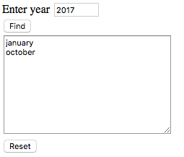

### Код сайту (what_week.html)

<!doctype html>

<html>

<head>

<meta charset='utf-8'>

<title>What week?</title>

</head>

<script>

function get_week() {

var y = Number(form1.year.value);

var m = Number(form1.mounth.value) - 1;

var d = Number(form1.day.value) - 1;

var date = new Date(y, m, d);

var onejan = new Date(date.getFullYear(), 0, 1);

form1.result.value = Math.ceil((((date - onejan) / 86400000) + onejan.getDay() + 1) / 7);

}

</script>

<body>

<form name='form1'>

Enter year <input type='text' size=8 name='year'><br>

Enter mounth <input type='text' size=8 name='mounth'><br>

Enter day <input type='text' size=8 name='day'><br>

<input type='button' value='What week?' onclick='get_week()'><hr>

<textarea name='result' cols=20 rows=10></textarea>

</form>

</body>

</html>

### Вигляд сайту (what_week.html)

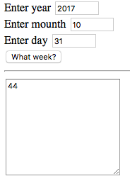

### Код сайту (year_name.html)

<!doctype html>

<html>

<head>

<meta charset='utf-8'>

<title>What year name?</title>

</head>

<script>

function get_year_name() {

var y = Number(form1.year.value) - 1;

var year_zero = 1983;

var colors = ['Green', 'Red', 'Yellow', 'White', 'Black'];

var animals = ['Rat', 'Cow', 'Tiger', 'Hare', 'Dragon', 'Snake', 'Horse', 'Sheep', 'Monkey', 'Hen', 'Dog', 'Pig'];

while (Math.abs(year_zero - y) >= 60) {

if (y > year_zero) {

y -= 60;

} else {

y += 60;

}

}

var delta = Math.abs(y - year_zero);

if (delta == 0) {

var color = colors[0];

var animal = animals[0];

} else {

var color = colors[Math.ceil(delta / 12)];

var animal = animals[delta % 12];

}

form1.result.value = color + ' ' + animal;

}

</script>

<body>

<form name='form1'>

<p>What is the name of the current year in the Eastern calendar?</p>

Enter year <input type='text' size=8 name='year'><br>

<input type='button' value='Want know!' onclick='get_year_name()'><hr>

Year name<br>

<textarea name='result' cols=20 rows=10></textarea>

</form>

</body>

</html>

### Вигляд сайту (year_name.html)

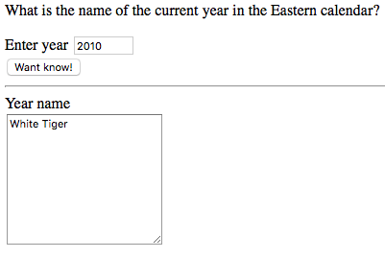

### Код сайту (zodiac_sign.html)

<!doctype html>

<html>

<head>

<meta charset='utf-8'>

<title>Zodiac sign</title>

</head>

<script>

function get_sign(obj) {

var m = Number(obj.mounth.value) - 1;

var d = Number(obj.day.value) - 1;

var sign = '';

if (m == 0) {

if (d >= 20) {

sign = 'Aquarius';

} else {

sign = 'Capricorn';

}

} else if (m == 1) {

if (d >= 19) {

sign = 'Pisces';

} else {

sign = 'Aquarius';

}

} else if (m == 2) {

if (d >= 21) {

sign = 'Aries';

} else {

sign = 'Pisces';

}

} else if (m == 3) {

if (d >= 20) {

sign = 'Taurus';

} else {

sign = 'Aries';

}

} else if (m == 4) {

if (d >= 21) {

sign = 'Gemini';

} else {

sign = 'Taurus';

}

} else if (m == 5) {

if (d >= 21) {

sign = 'Cancer';

} else {

sign = 'Gemini';

}

} else if (m == 6) {

if (d >= 23) {

sign = 'leo'

} else {

sign = 'Cancer';

}

} else if (m == 7) {

if (d >= 23) {

sign = 'Virgo';

} else {

sign = 'leo';

}

} else if (m == 8) {

if (d >= 23) {

sign = 'Libra';

} else {

sign = 'Virgo';

}

} else if (m == 9) {

if (d >= 23) {

sign = 'Scorpio';

} else {

sign = 'Libra';

}

} else if (m == 10) {

if (d >= 22) {

sign = 'Saggitarius';

} else {

sign = 'Scorpio';

}

} else if (m == 11) {

if (d >= 22) {

sign = 'Capricorn';

} else {

sign = ' Saggitarius';

}

}

form1.result.value = sign;

}

</script>

<body>

<form name='form1'>

<p>I know your Zodiak sign.</p>

Enter mounth <input type='text' size=8 name='mounth'><br>

Enter day <input type='text' size=8 name='day'><br>

<input type='button' value='Calculate' onclick='get_sign(form1)'><hr>

Your Zodiac sign<br>

<input type='text' size=10 name='result'>

</form>

</body>

</html>

### Вигляд сайту (zodiac_sign.html)

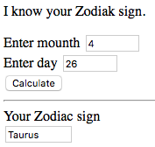

## Лабораторна робота 10

### Код сайту (calculate_words.html)

<!doctype html>

<html>

<head>

<meta charset='utf-8'>

<title>Calc words</title>

</head>

<script>

function count() {

var str = repeating.my_string.value;

var arr = str.split(' ');

repeating.result.value = arr.length;

}

</script>

<body>

<form name='repeating'>

<p>How much words are in the text?</p>

Enter string <input type='text' name='my_string'><br>

<input type='button' value='Count words' onclick='count()'><br>

<input type='text' name='result'>

</form>

</body>

</html>

### Вигляд сайту (calculate_words.html)

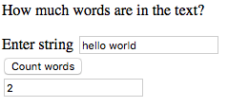

### Код сайту (chars_in_col.html)

<!doctype html>

<html>

<head>

<meta charset='utf-8'>

<title>In column</title>

</head>

<script>

function get_string() {

var str = process_str.my_string.value;

for (var i = 0; i < str.length; i++) {

process_str.result.value += str.charAt(i) + '\n';

}

}

</script>

<body>

<form name='process_str'>

<p>Enter string</p>

<input type='text' name='my_string' size=20><br>

<p>Get string in column char by char</p>

<input type='button' value='Get' onclick='get_string()'><hr>

<textarea name='result' cols=20 rows=10></textarea>

</form>

</body>

</html>

### Вигляд сайту (chars_in_col.html)

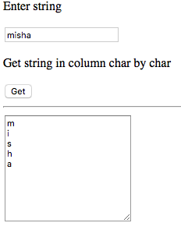

### Код сайту (replace_spaces.html)

<!doctype html>

<html>

<head>

<meta charset='utf-8'>

<title>Spaces replacing</title>

</head>

<script>

function space_replace() {

var str = replacing.my_string.value;

var arr = str.split(' ');

var new_arr = [];

var j = 0;

for (var i = 0; i < arr.length; i++) {

if (arr[i] != '') {

new_arr[j] = arr[i];

j++;

}

}

for (var i = 0; i < new_arr.length; i++) {

replacing.result.value += new_arr[i] + ' ';

}

}

</script>

<body>

<form name='replacing'>

<p>Replace multiple spaces by one space.</p>

Enter string <input type='text' name='my_string'><br>

<input type='button' value='Wanna know' onclick='space_replace()'><br>

<input type='text' name='result'><br>

<input type='reset'>

</form>

</body>

</html>

### Вигляд сайту (replace_spaces.html)

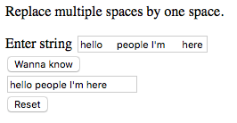

### Код сайту (replace_words.html)

<!doctype html>

<html>

<head>

<meta charset='utf-8'>

<title>Word replacing</title>

</head>

<script>

function replace_word() {

var str = repeating.my_string.value;

var find = repeating.find.value;

var replace = repeating.replace.value;

repeating.result.value = str.replace(new RegExp(find, 'g'), replace);

}

</script>

<body>

<form name='repeating'>

<p>How many times word is in text?</p>

Enter string <input type='text' name='my_string'><br>

Word to find <input type='text' name='find'><br>

Word to replace on <input type='text' name='replace'><br>

<input type='button' value='Wanna know' onclick='replace_word()'><br>

<input type='text' name='result'>

</form>

</body>

</html>

### Вигляд сайту (replace_words.html)

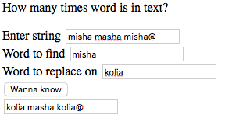

### Код сайту (word_numb.html)

<!doctype html>

<html>

<head>

<meta charset='utf-8'>

<title>Word repeating</title>

</head>

<script>

function calculate() {

var str = repeating.my_string.value;

var word = repeating.word.value;

var arr = str.split(' ');

var counter = 0;

for (var i = 0; i < arr.length; i++) {

if (arr[i] == word) {

counter++;

}

}

repeating.result.value = counter;

}

</script>

<body>

<form name='repeating'>

<p>How many times word is in text?</p>

Enter string <input type='text' name='my_string'><br>

Searching word <input type='text' name='word'><br>

<input type='button' value='Wanna know' onclick='calculate()'><br>

<input type='text' name='result'>

</form>

</body>

</html>

### Вигляд сайту (word_numb.html)

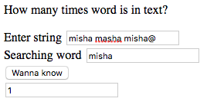

## Лабораторна робота 11

### Код сайту (binary_search.html)

<!doctype html>

<html>

<head>

<meta charset='utf-8'>

<title>Binary search</title>

</head>

<script>

var v = new Array (2, 3, 5, 6, 6, 7,10,11, 20, 25);

function testtab(obj, v, t) {

var res = "i j k v[k] t<= v[k]" + "\r\n";

var i = 0;

var j = v.length - 1;

var k;

while (i < j) {

k = Math.round((i + j) / 2 + 0.5) - 1;

res += i + " " + j + " " + k + " " + "v[" + k + "]=" + v[k] + " " + t + "<=" + v[k] + "\r\n";

if (t <= v[k]) {

j = k;

} else {

i = k + 1;

}

res += "v[" + i + "]=" + v[i] + "\r\n";

obj.result1.value=res;

if (v[i] ==t) {

return i;

} else {

return -1;

}

}

}

function test(obj) {

obj.data1.value = v;

}

</script>

<body>

<h4>Binary search</h4>

<form name='form1'>

<pre>

Array: <input type='text' size=40 name=data1><hr>

Element: <input type='text' size=20 name=data2><hr>

Result of search: <input type='text' size=20 name='result'><hr>

Table of intermediate values: <br>

<textarea cols=50 rows=7 name="result1" ></textarea><hr>

</pre>

<input type='button' value='Determine' onclick='test(form1); form1.result.value=testtab(form1,v,form1.data2.value)'>

<input type='reset'>

</form>

</body>

</html>

### Вигляд сайту (binary_search.html)

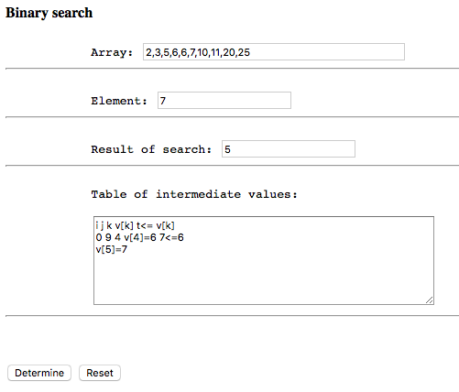

### Код сайту (images.html)

<!doctype html>

<html>

<head>

<meta charset='utf-8'>

<title>Images</title>

</head>

<script>

var img_array = ['img/img1.jpg', 'img/img2.jpg', 'img/img3.jpg'];

var i = 0;

function s() {

document.images[0].src = img_array[i];

i += 1;

if (i == 3) {

i = 0;

}

}

</script>

<body>

<img src='img/img1.jpg'><br>

<input type='button' name='show_me' value='Watch' onclick='setInterval("s()", 100)'>

</body>

</html>

### Вигляд сайту (images.html)

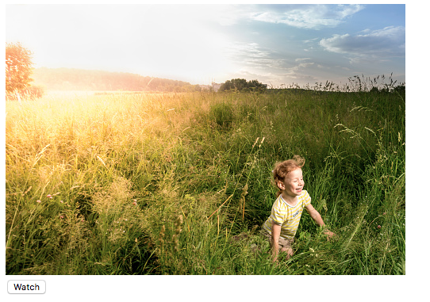

### Код сайту (max_number.html)

<!doctype html>

<html>

<head>

<meta charset='utf-8'>

<title>Max number</title>

</head>

<script>

var arr = [5, -1, 10, 3, 0, -3, -3, 8, -7, -13];

var max_numb = arr[0];

for (var i = 1; i < arr.length; i++) {

if (arr[i] > max_numb) {

max_numb = arr[i]

}

}

alert('Max number in the array = ' + max_numb);

</script>

<body>

</body>

</html>

### Вигляд сайту (max_number.html)

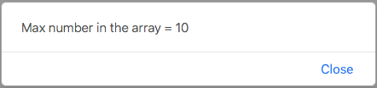

### Код сайту (multiplication.html)

<!doctype html>

<html>

<head>

<meta charset='utf-8'>

<title>Image gallery</title>

</head>

<script>

var img_array = ['img/img1.jpg', 'img/img2.jpg', 'img/img3.jpg'];

var i = 0;

function prev() {

i--;

if (i < 0 || i > 2) {

i = 2;

}

document.images[0].src = img_array[i];

}

function next() {

i++;

if (i < 0 || i > 2) {

i = 0;

}

document.images[0].src = img_array[i];

}

</script>

<body>

<center>

<h3>Image gallery</h3>

<img src='img/img1.jpg'><br>

<input type='button' value='prev' onclick='prev()'>

<input type='button' value='next' onclick='next()'>

</center>

</body>

</html>

### Вигляд сайту (multiplication.html)

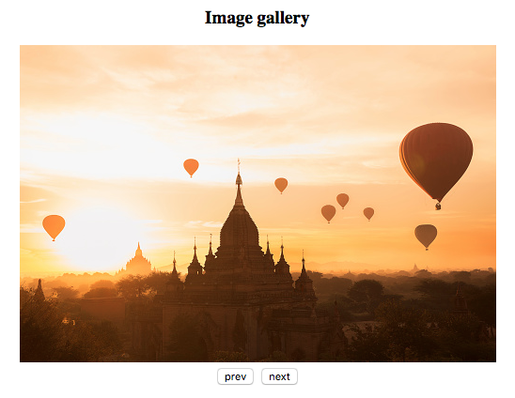

### Код сайту (positive_numbers.html)

<!doctype html>

<html>

<head>

<meta charset='utf-8'>

<title>Positive numbers</title>

</head>

<script>

var arr = [5, -1, 10, 3, 0, -3, -3, 8, -7, -13];

var counter = 0;

for (var i = 0; i < arr.length; i++) {

if (arr[i] > 0) {

counter++;

}

}

alert('Number of positive elements in array = ' + counter);

</script>

<body>

</body>

</html>

### Вигляд сайту (positive_numbers.html)

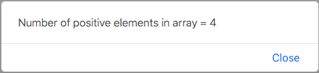

## Лабораторна робота 12

### Код сайту (check_user.html)

<!doctype html>

<html>

<head>

<meta charset='utf-8'>

<title>Check user</title>

</head>

<script>

function is_number(numb) {

var numbers = ["1", "2", "3", "4", "5", "6", "7", "8", "9", "0"];

if (numbers.includes(numb)) {

return true;

} else {

return false;

}

}

function check_form() {

var username = userinfo.username.value;

var email = userinfo.email.value;

if (username == '' || username.length < 3 || is_number(username[0])) {

alert('Username is incorrect!');

} else if (email == '' || email.search('@') == -1 || email[email.search('@')+1] == undefined) {

alert('Incorrect email adress!');

} else {

alert('The form is fullfilled correctly.');

}

}

</script>

<body>

<form name='userinfo'>

Enter your name <input type='text' name='username'><br>

Enter your email <input type='text' name='email'><br>

<input type='button' value='Check form' onclick='check_form()'>

</form>

</body>

</html>

### Вигляд сайту (check_user.html)

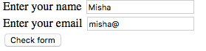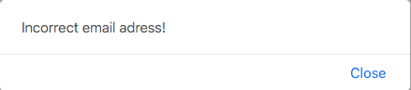

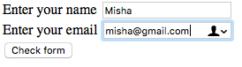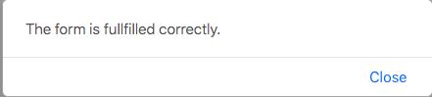

### Код сайту (phone_number.html)

<!doctype html>

<html>

<head>

<meta charset='utf-8'>

<title>Phone number</title>

</head>

<script>

function check_phone_number() {

var phone = user_input.phone_number.value;

var correct_values = ["1", "2", "3", "4", "5", "6", "7", "8", "9", "0", "/", "-", " "];

var phone_array = phone.split('');

var counter = 0;

var n = phone_array.length;

var clear_phone = [];

var j = 0;

for (var i = 0; i < n; i++) {

if (correct_values.includes(phone_array[i])) {

if (phone_array[i] != '/' && phone_array[i] != '-' && phone_array[i] != ' ') {

clear_phone[j] = phone_array[i];

j++;

}

counter++;

}

}

alert(clear_phone);

if (counter == n) {

if (clear_phone.length != 10) {

alert('Phone number must contain 10 digits!');

} else {

alert('Phone number is correct.');

}

} else {

alert('Incorrect characters in the phone number!');

}

}

</script>

<body>

<form name='user_input'>

Enter your phone number: <input type='text' name='phone_number'><br>

<input type='button' value='Check' onclick='check_phone_number()'>

</form>

</body>

</html>

### Вигляд сайту (phone_number.html)



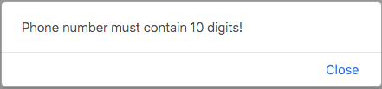



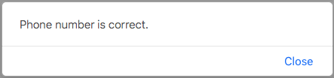

# PHP

## Лабораторна робота 2

### Код сайту (index.php)

<!doctype html>

<html>

<head>

<title>Lab 2</title>

<link rel="stylesheet" type="text/css" href="style/style.css">

</head>

<body>

<div id="text">Hello World!</div>

<?php include 'table1.html'; ?>

<?php include 'table2.html'; ?>

<?php include 'table3.html'; ?>

<?php include 'table4.html'; ?>

</body>

</html>

### Код сайту (table1.html)

<!-- First table -->

<div>3.1</div>

<table id="mytable">

<tr>

<td colspan="6" />

</tr>

<tr>

<td rowspan="5" />

<td colspan="5" />

</tr>

<tr>

<td rowspan="4" />

<td colspan="4" />

</tr>

<tr>

<td rowspan="3" />

<td colspan="3" />

</tr>

<tr>

<td rowspan="2" />

<td colspan="2" />

</tr>

<tr>

<td />

<td />

</tr>

</table>

### Код сайту (table2.html)

<!-- Second table -->

<div>3.2</div>

<table id="mytable">

<tr>

<td rowspan="8" />

<td colspan="6" />

</tr>

<tr>

<td rowspan="7" />

<td colspan="5" />

</tr>

<tr>

<td rowspan="6" />

<td colspan="4" />

</tr>

<tr>

<td rowspan="5" />

<td colspan="3" />

</tr>

<tr>

<td rowspan="4" />

<td colspan="2" />

</tr>

<tr>

<td rowspan="3" />

<td />

</tr>

<tr>

<td rowspan="2" />

</tr>

<tr>

</tr>

</table>

### Код сайту (table3.html)

<!-- Third table -->

<div>3.3</div>

<table id="mytable">

<tr>

<td colspan="2" />

<td colspan="2" />

<td colspan="2" />

<td />

</tr>

<tr>

<td />

<td colspan="2" />

<td colspan="2" />

<td colspan="2" />

</tr>

<tr>

<td colspan="2" />

<td colspan="2" />

<td colspan="2" />

<td />

</tr>

<tr>

<td />

<td colspan="2" />

<td colspan="2" />

<td colspan="2" />

</tr>

<tr>

<td colspan="2" />

<td colspan="2" />

<td colspan="2" />

<td />

</tr>

<tr>

<td />

<td colspan="2" />

<td colspan="2" />

<td colspan="2" />

</tr>

</table>

### Код сайту (table4.html)

<!-- Fourth table -->

<div>3.4</div>

<table id="mytable">

<tr>

<td rowspan="3" />

<td />

<td rowspan="2" />

<td rowspan="3" />

<td />

<td rowspan="2" />

<td rowspan="3" />

</tr>

<tr>

<td rowspan="3" />

<td rowspan="3" />

</tr>

<tr>

<td rowspan="3" />

<td rowspan="3" />

</tr>

<tr>

<!--<td rowspan="3" />-->

<td rowspan="3" />

<td rowspan="3" />

<td rowspan="3" />

</tr>

<tr>

<td rowspan="3" />

<td rowspan="3" />

</tr>

<tr>

<td rowspan="3" />

<td rowspan="3" />

</tr>

<tr>

<td rowspan="3" />

<td rowspan="3" />

<td rowspan="3" />

</tr>

<tr>

<td rowspan="3" />

<td rowspan="3" />

</tr>

</table>

### Вигляд сайту (index.php)

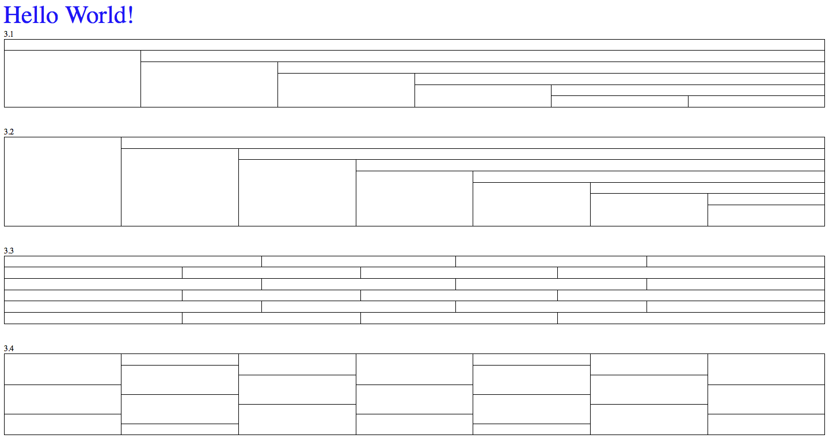

## Лабораторні роботи 3, 6, 7

### Код сайту (index.php)

<!doctype html>

<html>

<head>

<title>Lab 3</title>

</head>

<body>

<h3>1. This is simple php loop. Please enter start, end value and step of cycle to start.</h3>

<form action='loop.php' method='post'>

Start: <input type='text' name='start' /><br>

End: <input type='text' name='end' /><br>

Step: <input type='text' name='step' /><br>

<p><input type='submit'></p>

</form>

<h3>2. Automatically generated table.</h3>

<form action='generate_table.php' method='post'>

Number of table (1-4): <input type='text' name='table_numb' /><br>

Number of rows: <input type='text' name='n_rows' /><br>

Number of cols: <input type='text' name='n_cols' /><br>

<p><input type='submit'></p>

</form>

</body>

</html>

### Код сайту (connect.php)

<?php

//Connect to the database

$host = "127.0.0.1";

$user = "kushkamisha";

$pass = "";

$db = "mystorage";

$port = 3306;

$connection = mysqli_connect($host, $user, $pass, $db, $port)or die(mysql_error());

?>

### Код сайту (generate_table.php)

<link rel='stylesheet' href='../Lab2/style/style.css' />

<?php

$n_rows = intval($_POST['n_rows']);

$n_cols = intval($_POST['n_cols']);

$table_numb = intval($_POST['table_numb']);

// Check whether it is necessary to take data from database.

if ($n_rows == '' && $table_numb == '') {

echo '<p>The data will be from database.</p>';

include 'connect.php';

$result = mysqli_query($connection, 'SELECT * FROM my_table');

while ($row = mysqli_fetch_assoc($result)) {

$n_rows = intval($row['rows']);

$table_numb = intval($row['table_no']);

if ($table_numb == 3 || $table == 4) {

$n_cols = 7;

}

}

}

if (!is_int($n_rows) || !is_int($table_numb)) {

echo 'All values must be int type. Please try again.';

} else {

if ($table_numb == 1) {

if ($n_rows > 1) {

$table = '<div>Table 2.1 with '.$n_rows.' rows.</div><table id="mytable"><tr><td colspan="'.$n_rows.'" /></tr>';

while ($n_rows > 1) {

$n_rows -= 1;

$table .= '<tr><td rowspan="'.$n_rows.'" /><td colspan="'.$n_rows.'" /></tr>';

}

$table .= '</table>';

echo $table;

} else echo 'Enter bigger number for number of rows.';

}

else if ($table_numb == 2) {

if ($n_rows > 2) {

$table = '<div>Table 2.2 with '.$n_rows.' rows.</div>';

$table .= '<table id="mytable"><tr><td rowspan="'.$n_rows.'" /><td colspan="'.($n_rows-2).'" /></tr>';

while ($n_rows > 3) {

$n_rows -= 1;

$table .= '<tr><td rowspan="'.$n_rows.'" /><td colspan="'.($n_rows-2).'" /></tr>';

}

$table .= '<tr><td rowspan="2" /></tr><tr></tr></table>';

echo $table;

} else echo 'Enter bigger number for number of rows.';

}

else if ($table_numb == 3) {

if ($n_rows > 1) {

if ($n_cols > 2) {

$table = '<div>Table 2.3 with '.$n_rows.' rows.</div>';

$table .= '<table id="mytable">';

if ($n_rows % 2 != 0) {

$flag = 0;

} else {

$flag = 1;

}

$n_cols -= 2;

while ($n_rows > 0) {

$n = $n_cols;

if ($n_rows % 2 == $flag) {

$table .= '<tr><td /><td colspan="2" />';

while ($n > 0) {

$table .= '<td colspan="2" />';

$n -= 1;

}

$table .= '</tr>';

} else {

$table .= '<tr><td colspan="2" />';

while ($n > 0) {

$table .= '<td colspan="2" />';

$n -= 1;

}

$table .= '<td /></tr>';

}

$n_rows -= 1;

}

$table .= '</table>';

echo $table;

} else echo 'Enter bigger number for number of cols.';

} else echo 'Enter bigger number for number of rows.';

}

else if ($table_numb == 4) {

// if (($n_rows+1) % 3) {

// echo 'Number of rows in the table + 1 must divide without a remiender by 3.';

// } else {

if ($n_rows > 2) {

if ($n_cols > 2) {

$n_cols -= 3;

$table = '<div>Table 2.4 with '.$n_rows.' rows.</div><table id="mytable"><tr>';

$table .= '<td rowspan="3" /><td /><td rowspan="2" />';

$n = $n_cols;

$n_rows -= 1;

$counter = 1;

while ($n > 0) {

if ($n % 3 == 2) {

$table .= '<td />';

$counter += 1;

} else if ($n % 3 == 0) {

$table .= '<td rowspan="3" />';

} else if ($n % 3 == 1) {

$table .= '<td rowspan="2" />';

}

$n -= 1;

}

$table .= '</tr>';

$rows_counter = 1;

while ($n_rows > 0) {

$c = $counter;

$table .= '<tr>';

while ($c > 0) {

$table .= '<td rowspan="3" />';

$c -= 1;

}

if ($rows_counter % 3 == 0) {

$table .= '<td rowspan="3" />';

}

$table .= '</tr>';

$n_rows -= 1;

$rows_counter += 1;

}

$table .= '</table>';

echo $table;

} else echo 'Enter bigger number for number of cols.';

} else echo 'Enter bigger number for number of rows.';

// }

}

}

?>

### Код сайту (loop.php)

<?php

$start = intval($_POST['start']);

$end = intval($_POST['end']);

$step = intval($_POST['step']);

// Check whether it is necessary to take data from database.

if ($start == '' && $end == '' && $step == '') {

echo '<p>The data will be from database.</p>';

include 'connect.php';

$result = mysqli_query($connection, 'SELECT * FROM my_loop');

while ($row = mysqli_fetch_assoc($result)) {

$start = intval($row['start']);

$end = intval($row['end']);

$step = intval($row['step']);

}

}

if (!is_int($start) || !is_int($end) || !is_int($step)) {

echo 'All values must be int type. Please try again.';

} else {

echo '<h3>The cycle from '.$start.' to '.$end.' with step '.$step.' :</h3>';

if ($start < $end && $step > 0) {

for ($i=$start; $i<=$end; $i+=$step) echo $i.' ';

}

else if ($start > $end && $step > 0) {

for ($i=$start; $i>=$end; $i-=$step) echo $i.' ';

}

else {

echo 'Loop step must be greater than 0.';

}

// Save new start, end and step to my_loop table

include 'connect.php';

// Clear table

$sql = "TRUNCATE TABLE my_loop";

mysqli_query($connection, $sql) or die(mysqli_error());

$sql = mysqli_query($connection, 'INSERT INTO my_loop (start, end, step) VALUES ('.$start.', '.$end.', '.$step.')') or die(mysqli_error());

mysqli_close($connection);

}

?>

### Вигляд сайту (index.php)

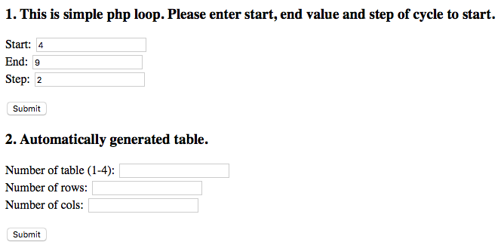

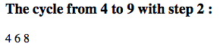

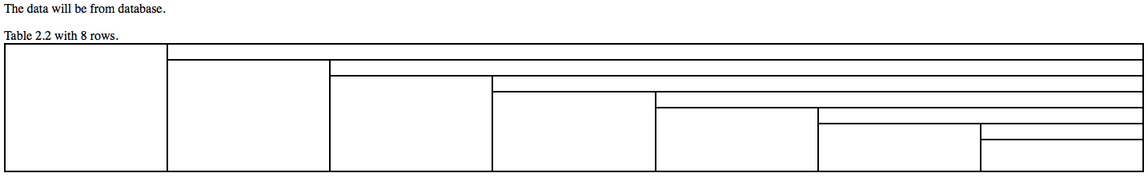

## Лабораторна робота 4

### Код сайту (index.php)

<!doctype html>

<html>

<head>

<title>Lab 4</title>

</head>

<body>

<h3>This is simple php loop. Please enter start, end value and step of cycle to start.</h3>

<form action='loop.php' method='post'>

Start: <input type='text' name='start' /><br>

Step: <input type='text' name='step' /><br>

End: <input type='text' name='end' /><br>

<p><input type='submit'></p>

</form>

</body>

</html>

### Код сайту (loop.php)

<?php

$start = $_POST['start'];

$step = $_POST['step'];

$end = $_POST['end'];

if ($start == '') {

echo 'Please fill "start" field.<br>';

}

if ($step == '') {

echo 'Please fill "step" field.<br>';

}

if ($end == '') {

echo 'Please fill "end" field.<br>';

}

$start = intval($start);

$step = intval($step);

$end = intval($end);

if ($start == 200 || $start == 150 || $start == 120) {

if ($step == 1 || $step == 2 || $step == 3) {

if ($end == 1 || $end == -1 || $end == 0) {

if ($start < $end) {

for ($i=$start; $i<=$end; $i+=$step) echo $i.' ';

} else {

for ($i=$start; $i>=$end; $i-=$step) echo $i.' ';

}

}

}

}

if ($start == 0 || $start == 1 || $start == 2) {

if ($step == 1 || $step == 10 || $step == 100) {

if ($end == 99 || $end == 199 || $end == 999) {

if ($start < $end) {

for ($i=$start; $i<=$end; $i+=$step) echo $i.' ';

} else {

for ($i=$start; $i>=$end; $i-=$step) echo $i.' ';

}

}

}

}

if ($start == 1 || $start == 0 || $start == -1) {

if ($step == 1 || $step == 2) {

if ($end == -99 || $end == 99 || $end == 0) {

if ($start < $end) {

for ($i=$start; $i<=$end; $i+=$step) echo $i.' ';

} else {

for ($i=$start; $i>=$end; $i-=$step) echo $i.' ';

}

}

}

}

if ($start == -100 || $start == 0 || $start == 100) {

if ($step == 4 || $step == 2 || $step == 3) {

if ($end == 2 || $end == -2 || $end == 0) {

if ($start < $end) {

for ($i=$start; $i<=$end; $i+=$step) echo $i.' ';

} else {

for ($i=$start; $i>=$end; $i-=$step) echo $i.' ';

}

}

}

}

?>

### Вигляд сайту (index.php)

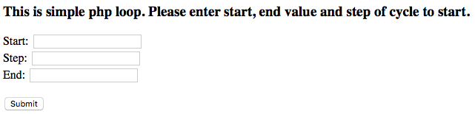



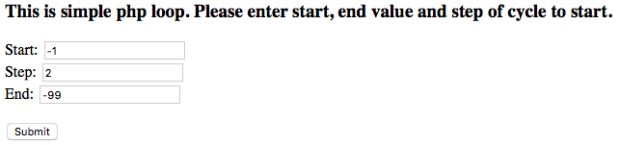



## Лабораторна робота 5

### Код сайту (index.php)

<!doctype html>

<html>

<head>

<title>Lab 5</title>

</head>

<body>

<h3>Select on of the following algoritms to sort array:</h3>

<form action='sort.php' method='post'>

<input type="radio" name="sort_method" value="Selection" checked> Selection<br>

<input type="radio" name="sort_method" value="Insertion"> Insertion<br>

<input type="radio" name="sort_method" value="Bogosort"> Bogosort<br>

<input type="radio" name="sort_method" value="Bubble sort"> Bubble sort<br>

<input type="radio" name="sort_method" value="Quicksort"> Quicksort<br>

<input type="radio" name="sort_method" value="Gnome sort"> Gnome sort<br>

<p><input type='submit' value='Sort!'></p>

</form>

</body>

</html>

### Код сайту (functions.php)

<?php

// display array

function show_array($array, $work_time) {

echo '<p>Sorted array: ';

for ($i=0; $i < count($array); $i+=1) {

echo $array[$i].'&nbsp;&nbsp;';

}

echo '</p> Method\'s work time: ';

printf('%.6f',$work_time);

echo ' sec';

}

// swap two elements in the array

function swap(&$array, $i, $j) {

$temp = $array[$i];

$array[$i] = $array[$j];

$array[$j] = $temp;

}

// for bogosort

function is_sorted($array) {

for ($i=0; $i < count($array)-1; $i+=1) {

if ($array[$i] > $array[$i+1]) {

return 0;

}

}

return 1;

}

function selection($array) {

$list = $array;

for ($i=0; $i < count($array); $i+=1) {

$min_index = $i;

for ($j=$i+1; $j<count($array); $j+=1) {

if ($array[$j] < $array[$min_index]) {

$min_index = $j;

}

}

if ($min_index != $i) {

swap($array, $i, $min_index);

}

}

return $array;

}

function insertion($array) {

for ($i=0; $i < count($array); $i+=1) {

$j = $i;

while ($j > 0 && $array[$j] < $array[$j-1]) {

swap($array, $j, $j-1);

$j -= 1;

}

}

return $array;

}

function bogosort($array) {

while (!is_sorted($array)) {

shuffle($array);

}

return $array;

}

function bubble_sort($array) {

for ($i=0; $i < count($array); $i+=1) {

for ($j=0; $j < count($array)-1; $j+=1) {

if ($array[$j] > $array[$j+1]) {

swap($array, $j, $j+1);

}

}

}

return $array;

}

function quicksort($array) {

if(count($array) <= 1) {

return $array;

}

$left = $right = array();

reset($array);

$pivot_key = key($array);

$pivot = array_shift($array);

foreach($array as $k => $v) {

if($v < $pivot)

$left[$k] = $v;

else

$right[$k] = $v;

}

return array_merge(quicksort($left), array($pivot_key => $pivot), quicksort($right));

}

function gnome_sort($array) {

$i = 1;

while ($i < count($array)) {

if (!$i || $array[$i-1] <= $array[$i]) {

$i += 1;

} else {

swap($array, $i, $i-1);

$i -= 1;

}

}

return $array;

}

?>

### Код сайту (sort.php)

<?php

include 'functions.php';

// generate random array with 10 elements

$array = array();

for ($i=0; $i<10; $i+=1) {

$array[$i] = rand(-10, 10);

}

$sort_method = $_POST['sort_method'];

echo '<p>Array to sort: ';

for ($i=0; $i < count($array); $i+=1) {

echo $array[$i].'&nbsp;&nbsp;';

}

echo '</p><p>Your method of sort: '.$sort_method.'</p>';

if ($sort_method == 'Selection') {

$start_time = microtime();

$sorted = selection($array);

$end_time = microtime();

show_array($sorted, $end_time-$start_time);

} else if ($sort_method == 'Insertion') {

$start_time = microtime();

$sorted = insertion($array);

$end_time = microtime();

show_array($sorted, $end_time-$start_time);

} else if ($sort_method == 'Bogosort') {

$start_time = microtime();

$sorted = bogosort($array);

$end_time = microtime();

show_array($sorted, $end_time-$start_time);

} else if ($sort_method == 'Bubble sort') {

$start_time = microtime();

$sorted = bubble_sort($array);

$end_time = microtime();

show_array($sorted, $end_time-$start_time);

} else if ($sort_method == 'Quicksort') {

$start_time = microtime();

$sorted = quicksort($array, 0, count($array));

$end_time = microtime();

show_array($sorted, $end_time-$start_time);

} else if ($sort_method == 'Gnome sort') {

$start_time = microtime();

$sorted = gnome_sort($array);

$end_time = microtime();

show_array($sorted, $end_time-$start_time);

}

?>

### Вигляд сайту (index.php)

